**CHAT APPLICATION PROJECT**

**KUNAL JHA**

**IIT PATNA**

**Github link -** [**https://github.com/kunal7456/Chat-App**](https://github.com/kunal7456/Chat-App)

**User Authorization :**

So firstly the login screen looks something like this . We are required to sign up first giving our name , mail , password and profile pic . Below is what it looks like :

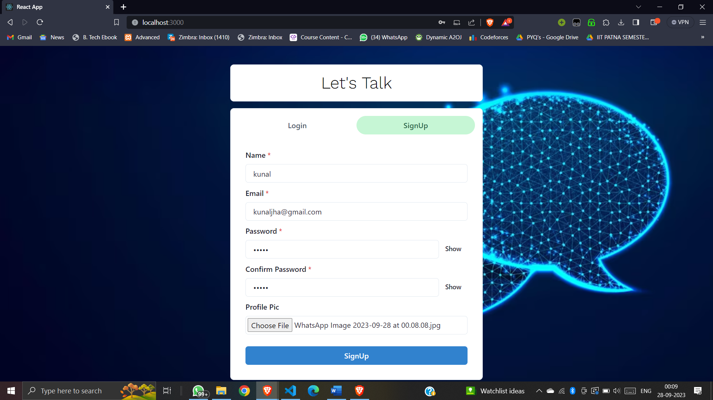

Then we are required to login with the same gmail and password .

After logging in this is what the home screen looks like .

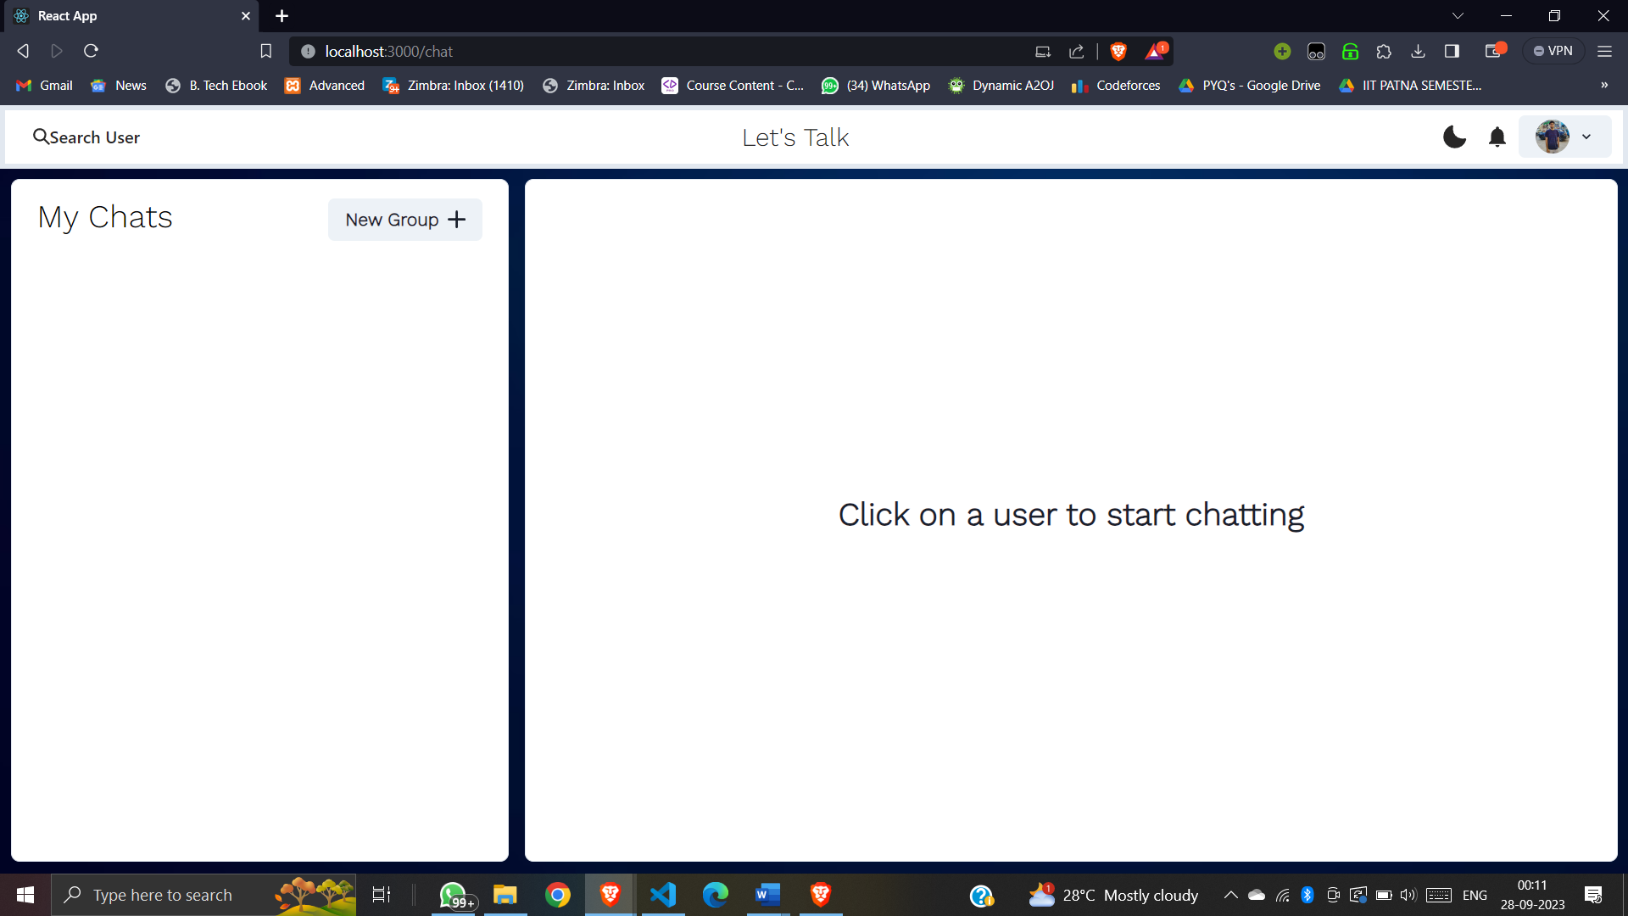

After clicking my profile pic , we can do the following things :

i)view my profile by clicking my profile .

ii)update my profile by changing username and profile picture .

iii) logout my profile and move to user authorization screen .

Below is how it is :

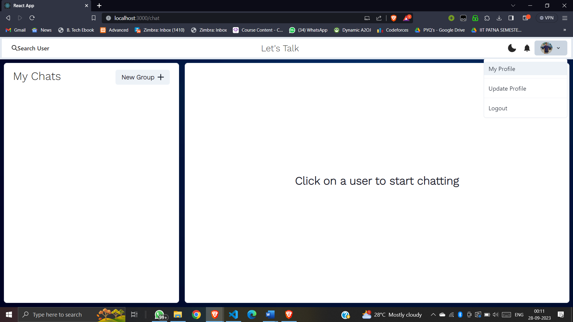

If I click on my profile , basic information appears on screen as shown .

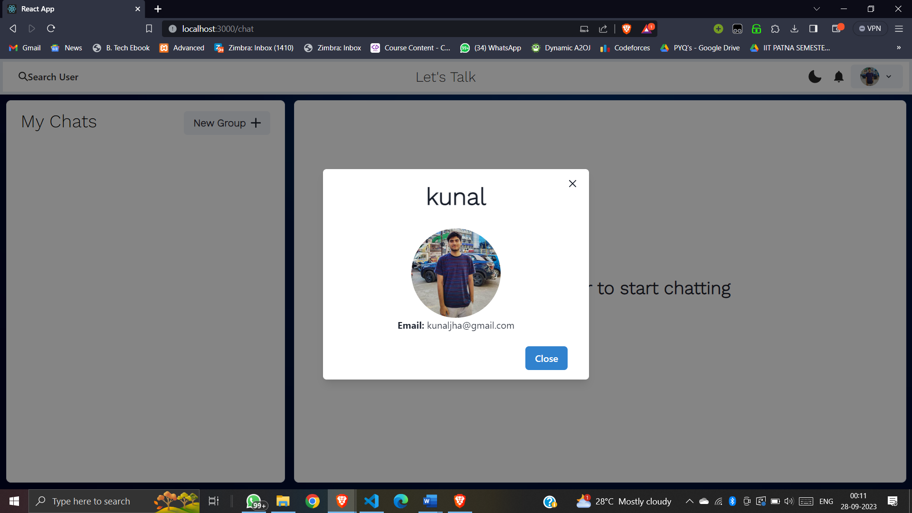

There is a “**Search Users**” function as well through which we can search users who have made their account in past in web . Below , I am searching an account which I have made .

s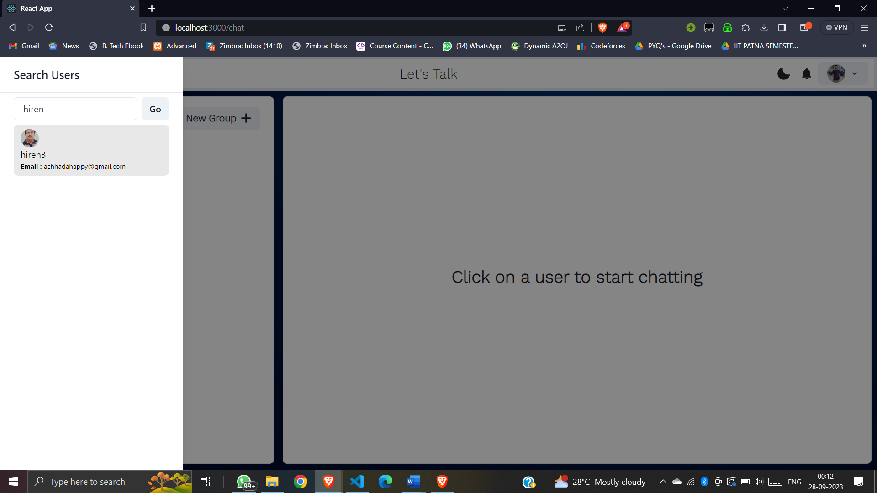

Now I am chatting with a second user with name “Kunal12” in real time .

Download chat Video call Schedule mssg

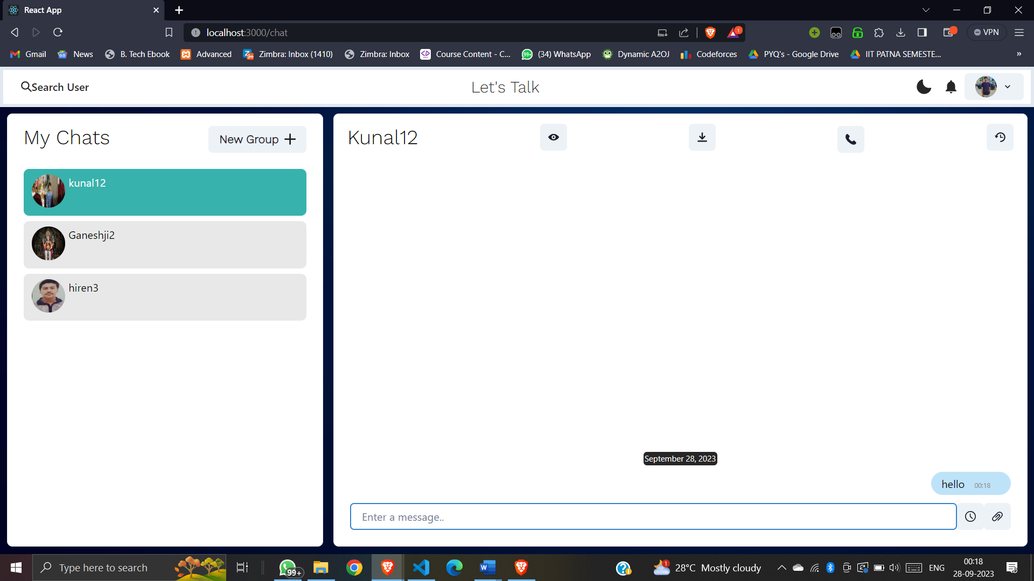

Now if I login with the account Kunal12(second user ) I can see message popping up (from kunal) . Also there is a feature of “dark mode” as well .

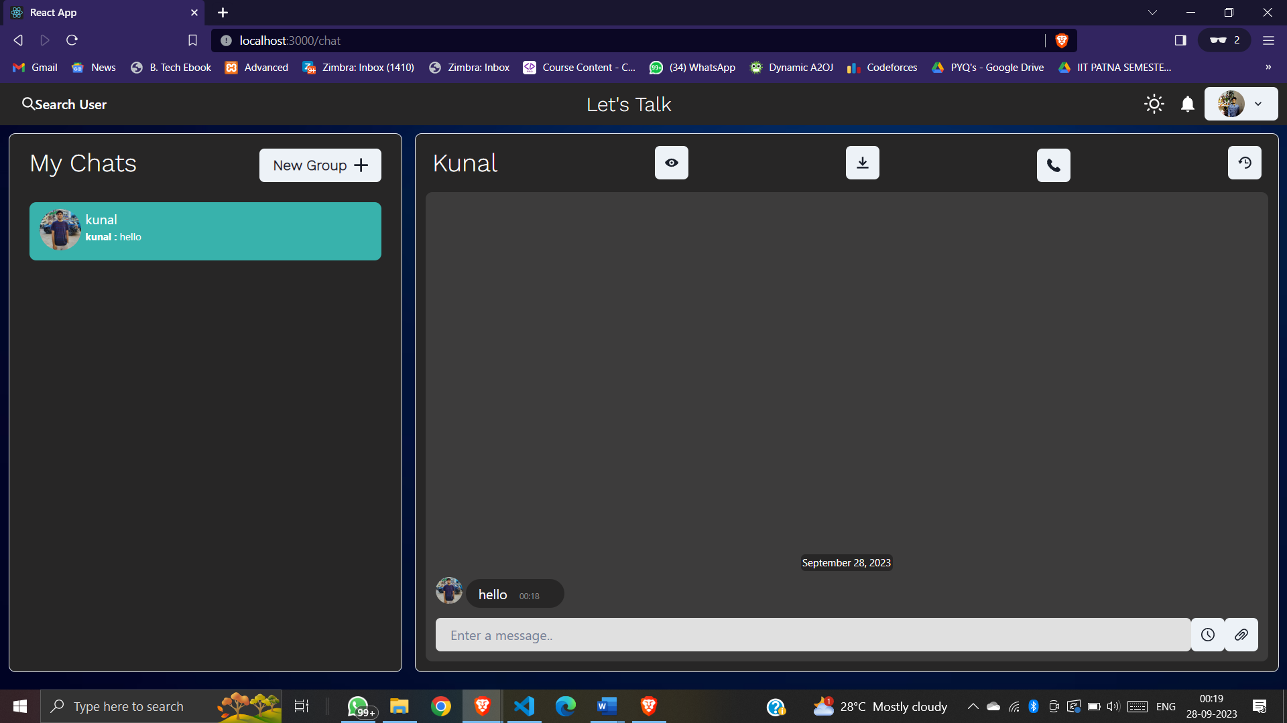

Now from second user id , I wrote a message to kunal which appeared in the chat .

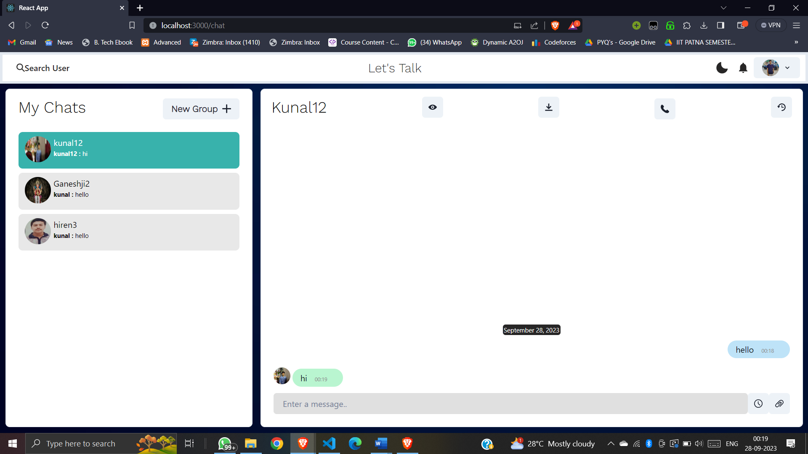

We can also send photos as well as documents in the chat as shown . I sent a photo to second user id.

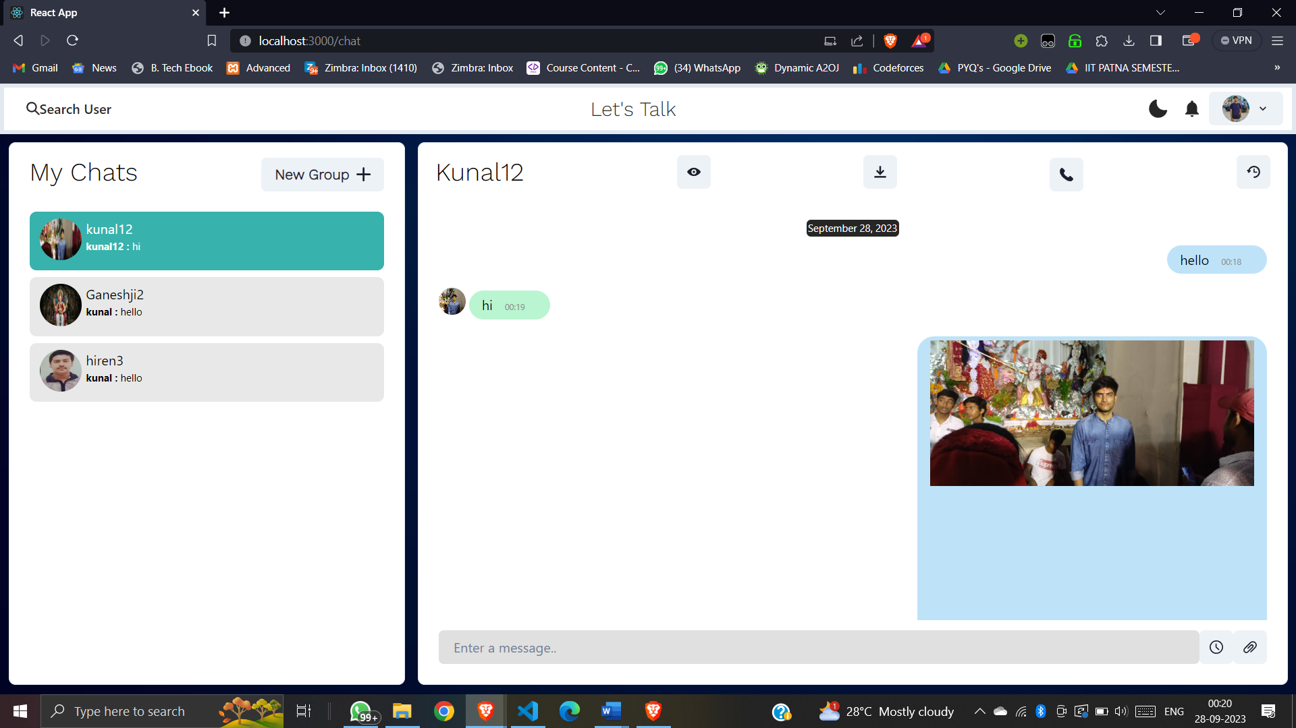

The photo was received in the second user id.

Creating a group

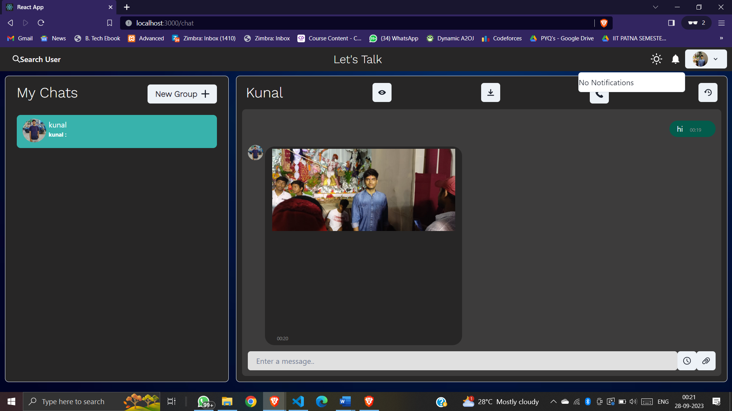

Now from the second user id I sent a document which was received and we can download it easily in our device .

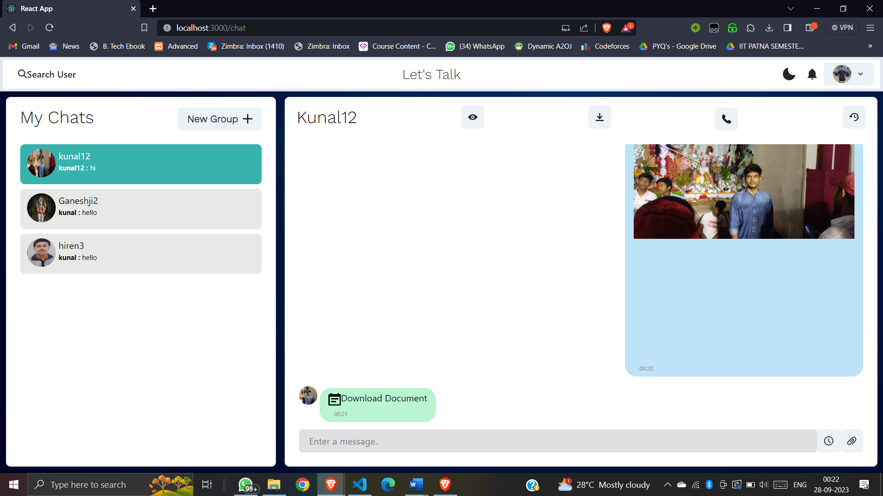

We can download the doc in our device .

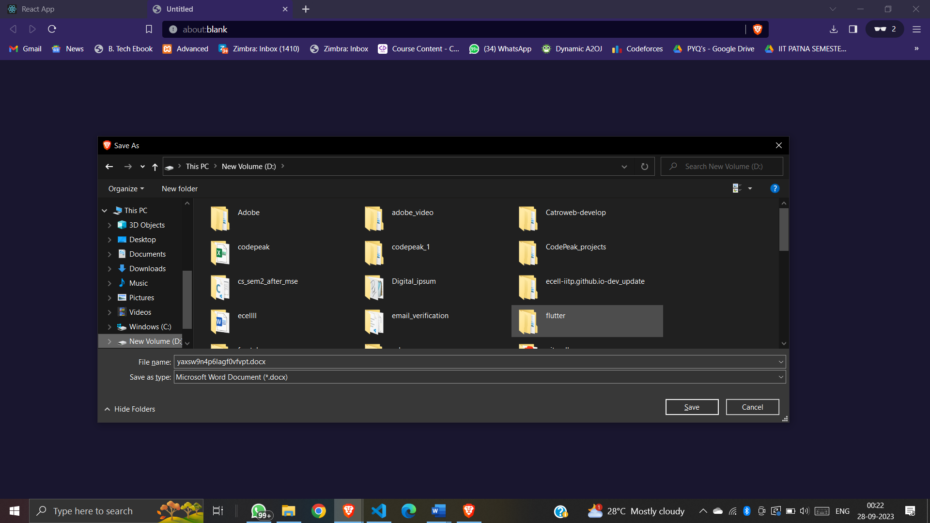

Now there is a **Group chat** functionality in which we can chat with our friends in a group . We can name the group , search for users which we want in the group and provide a profile pic to group .

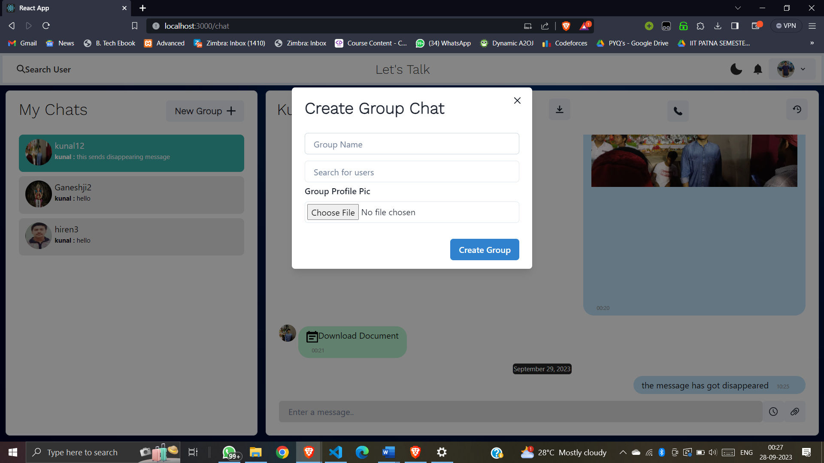

We should also add atleast 2 members in the group . If we want to create the group with only one member it will throw an error as shown .

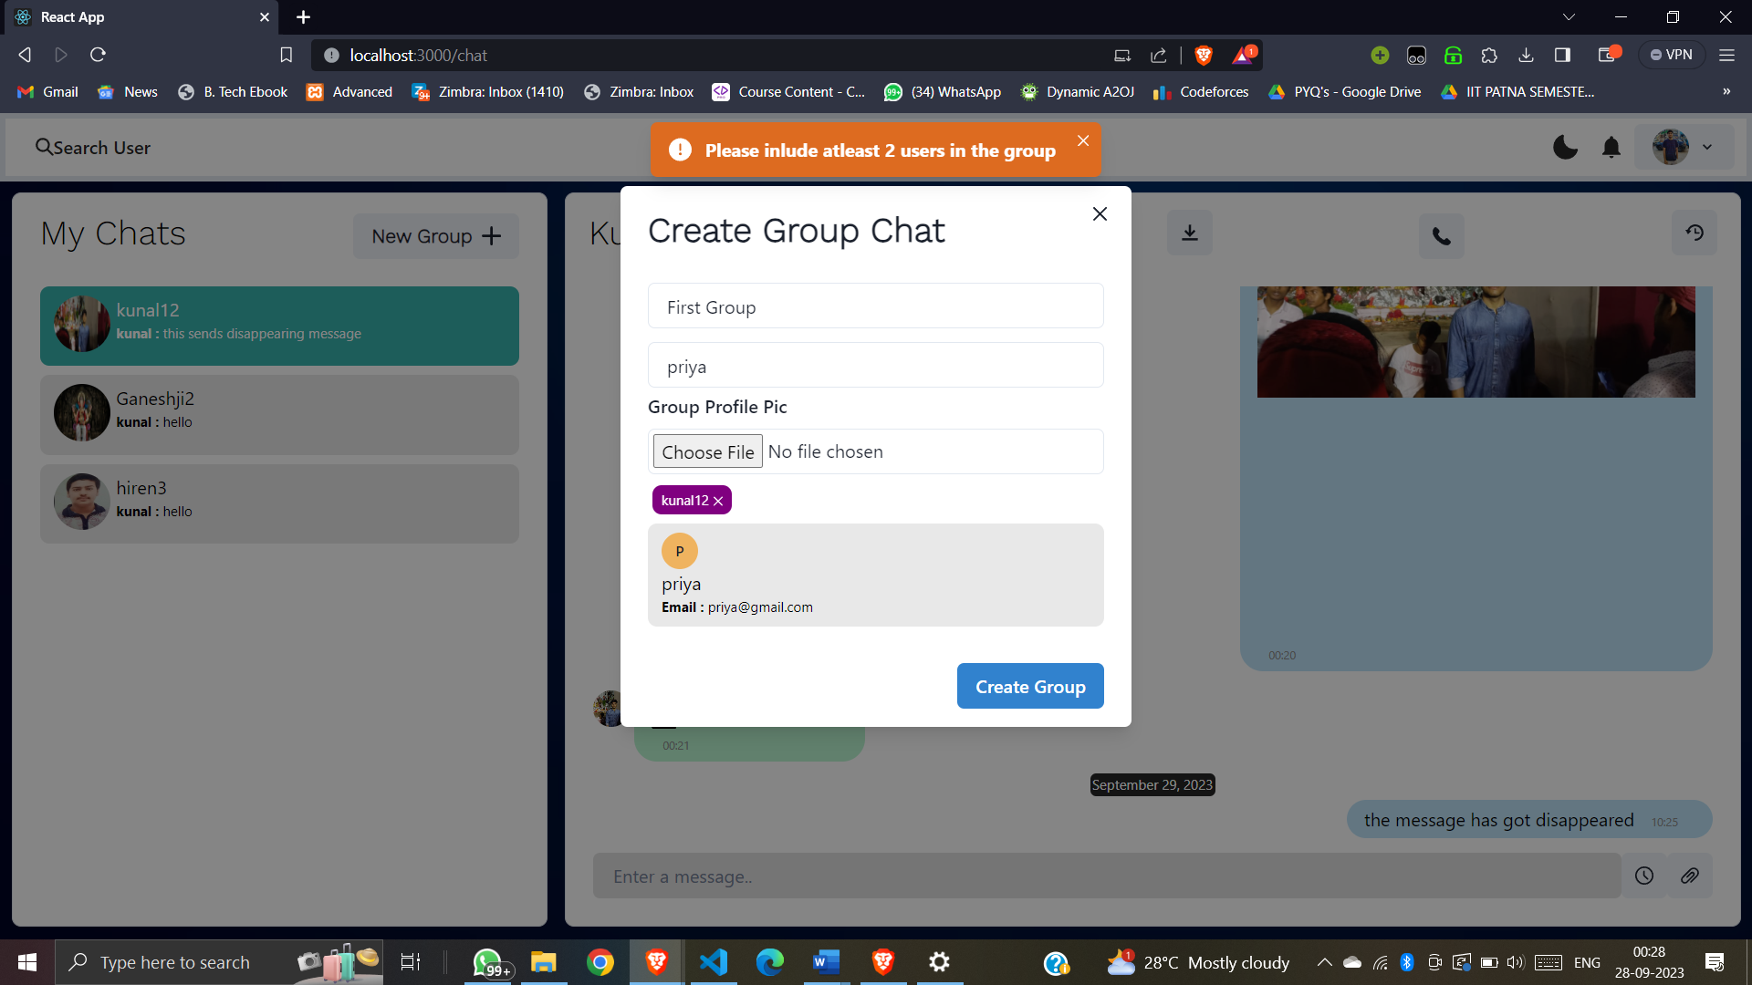

Now I am creating a group named as “First Group ” with three members in it .

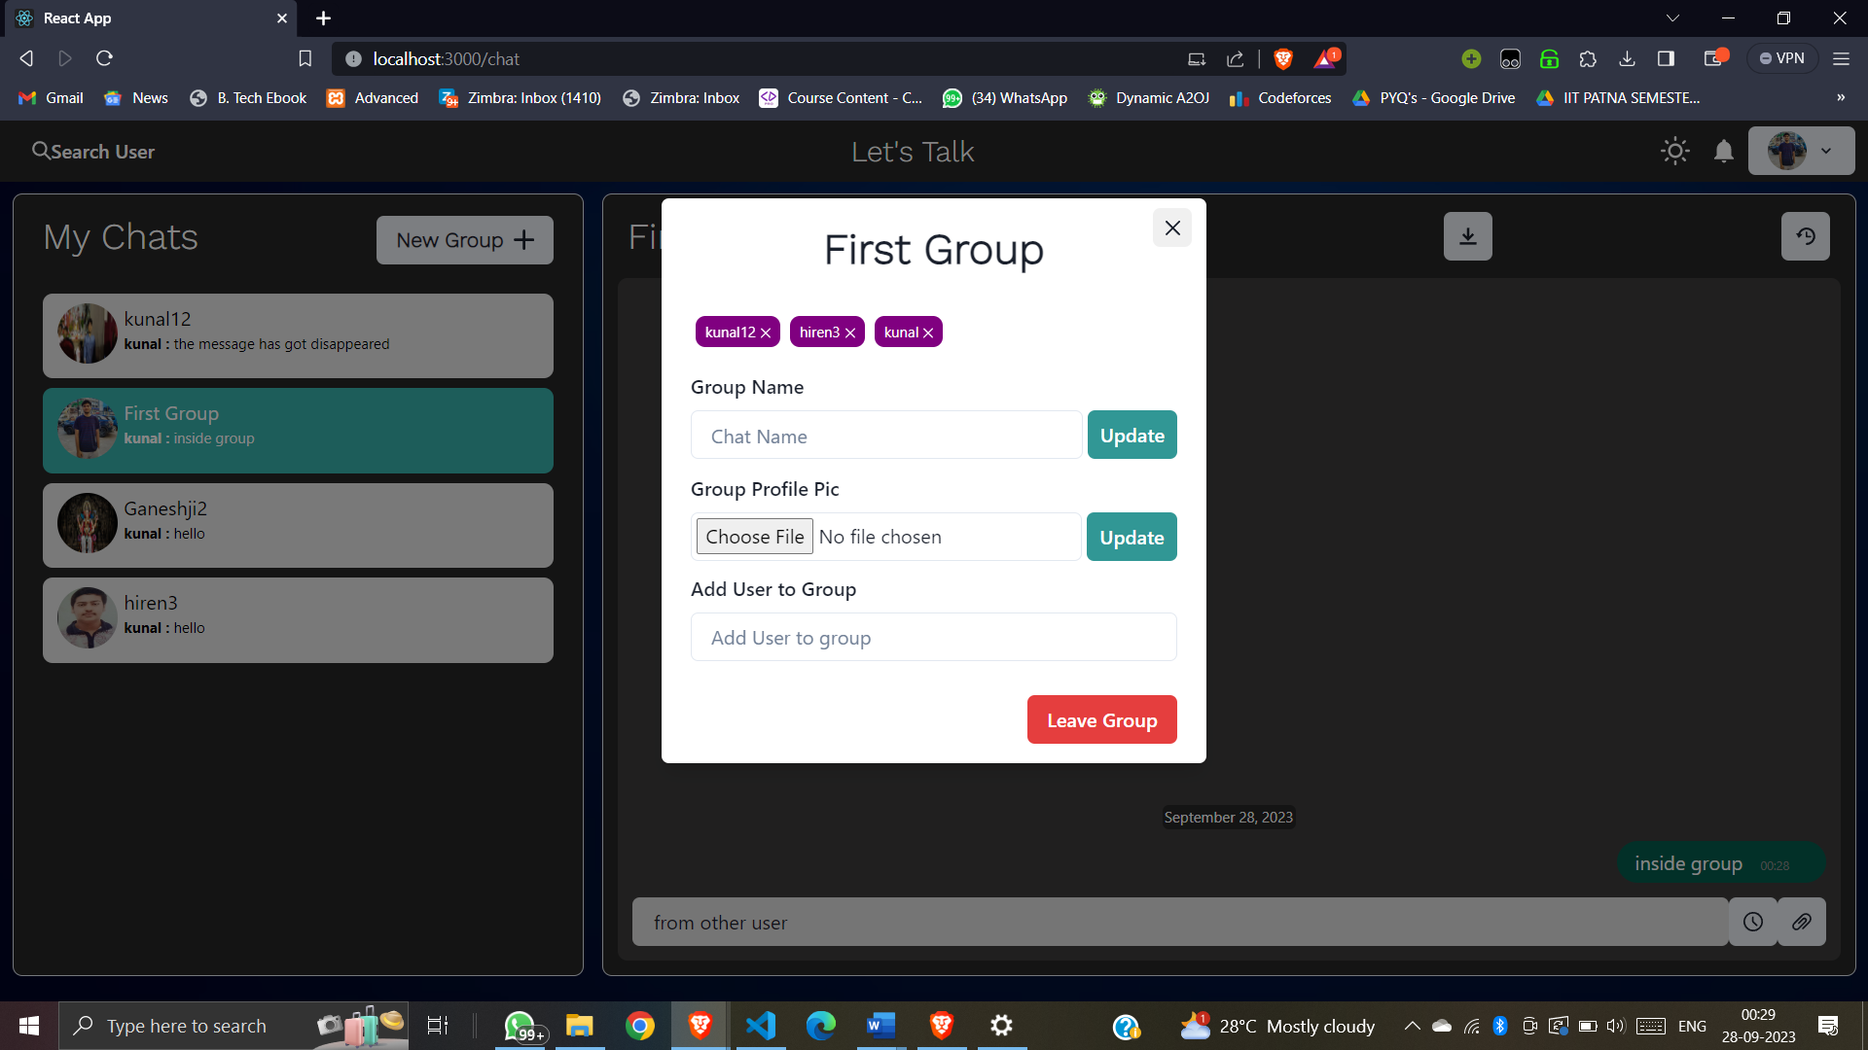

Now we can chat in the group as well .

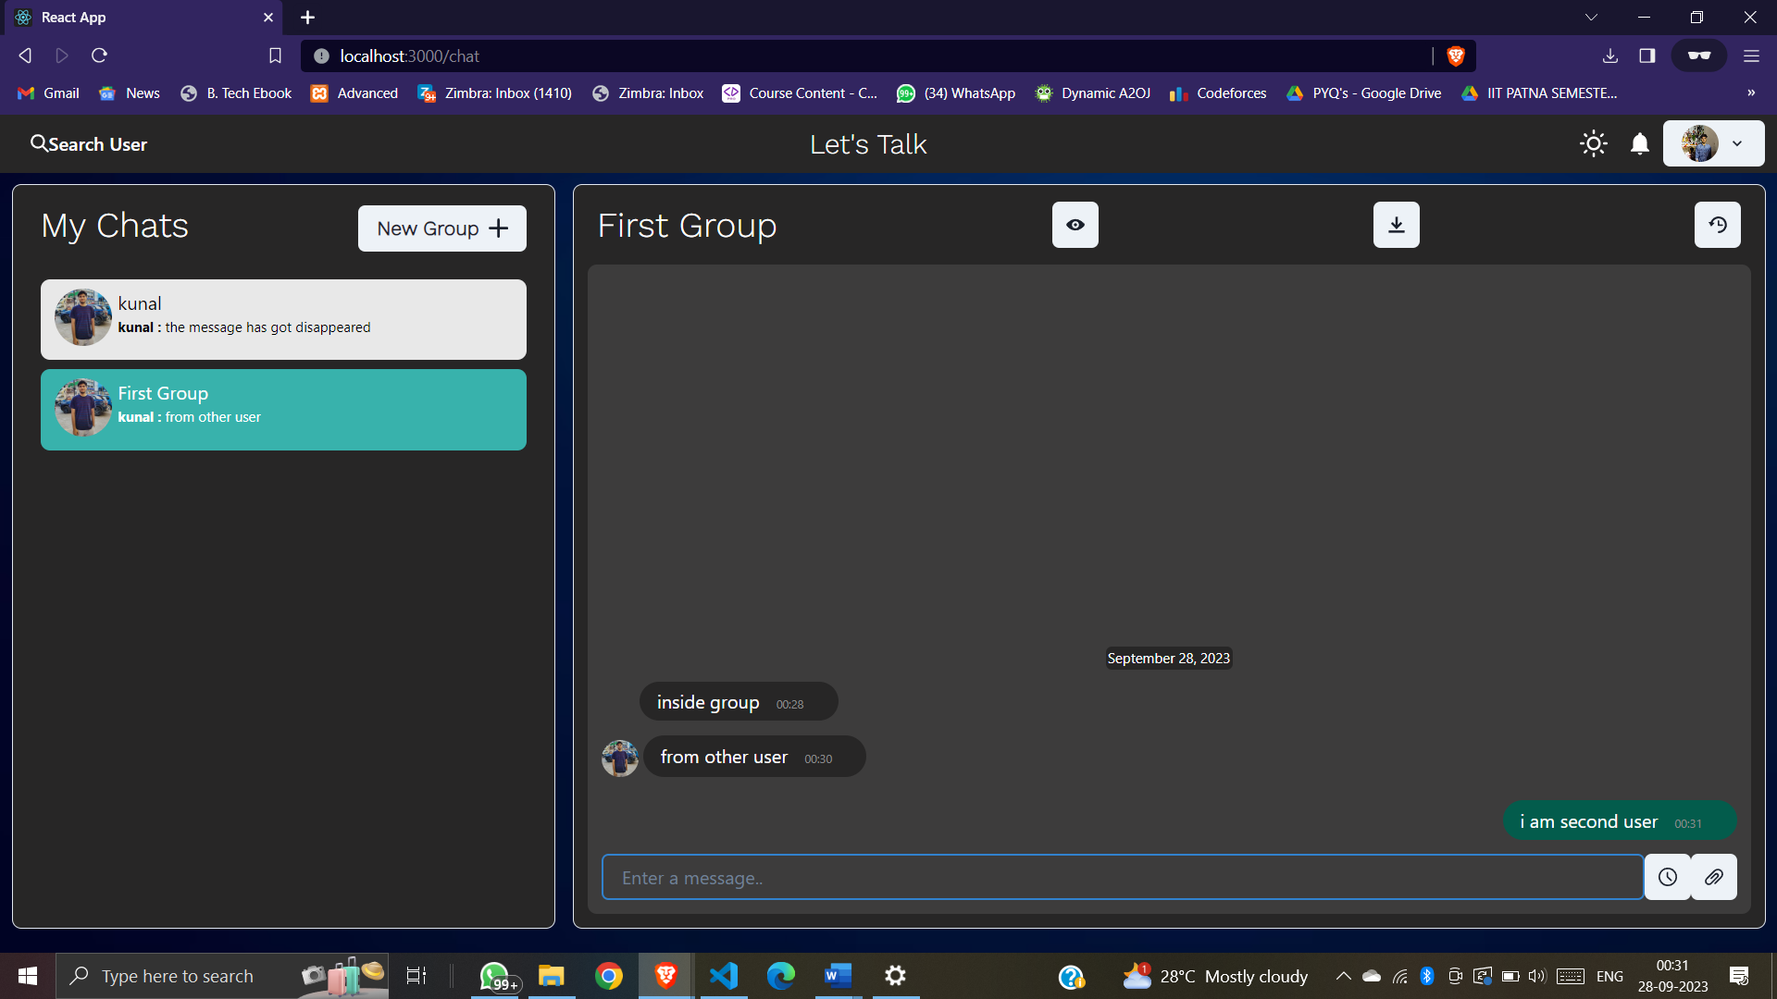

There is also a feature in which we can download all the chats in .txt format by clicking the download symbol .

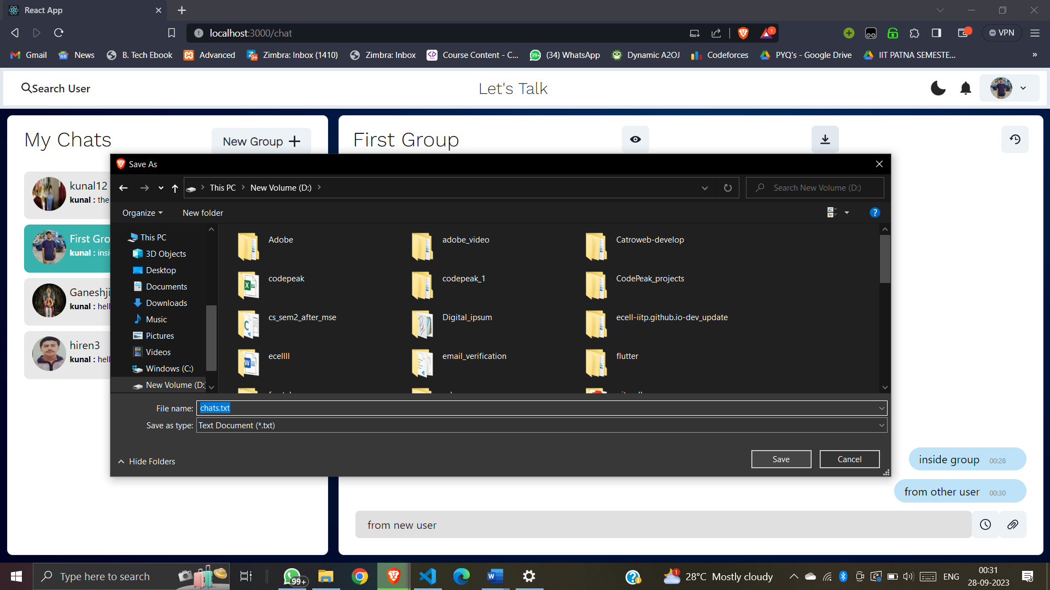

The chats got downloaded .

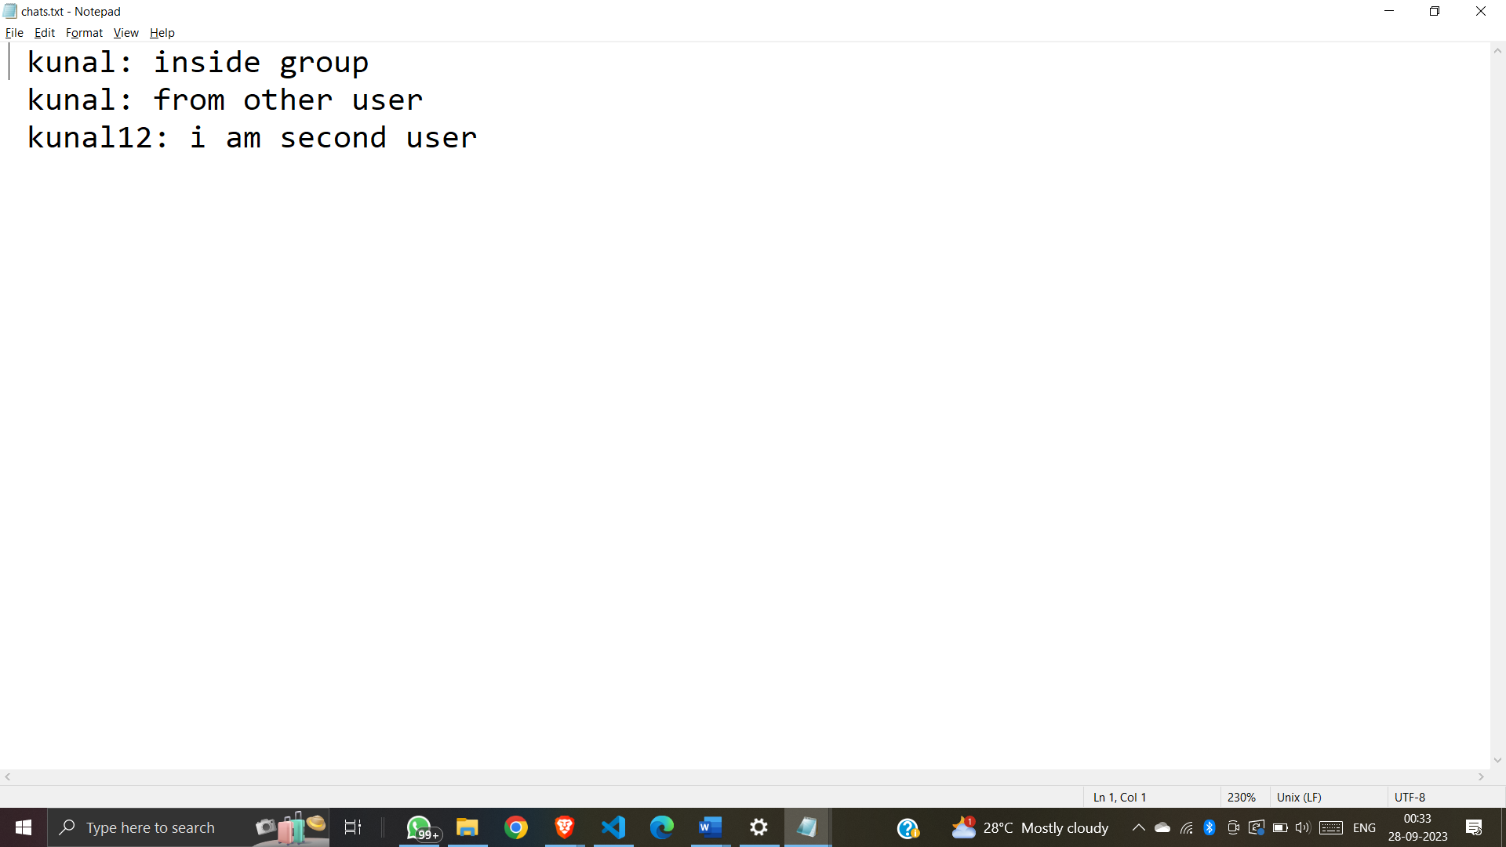

There is also a feature in which we can schedule message to be sent to someone at a scheduled time as shown .

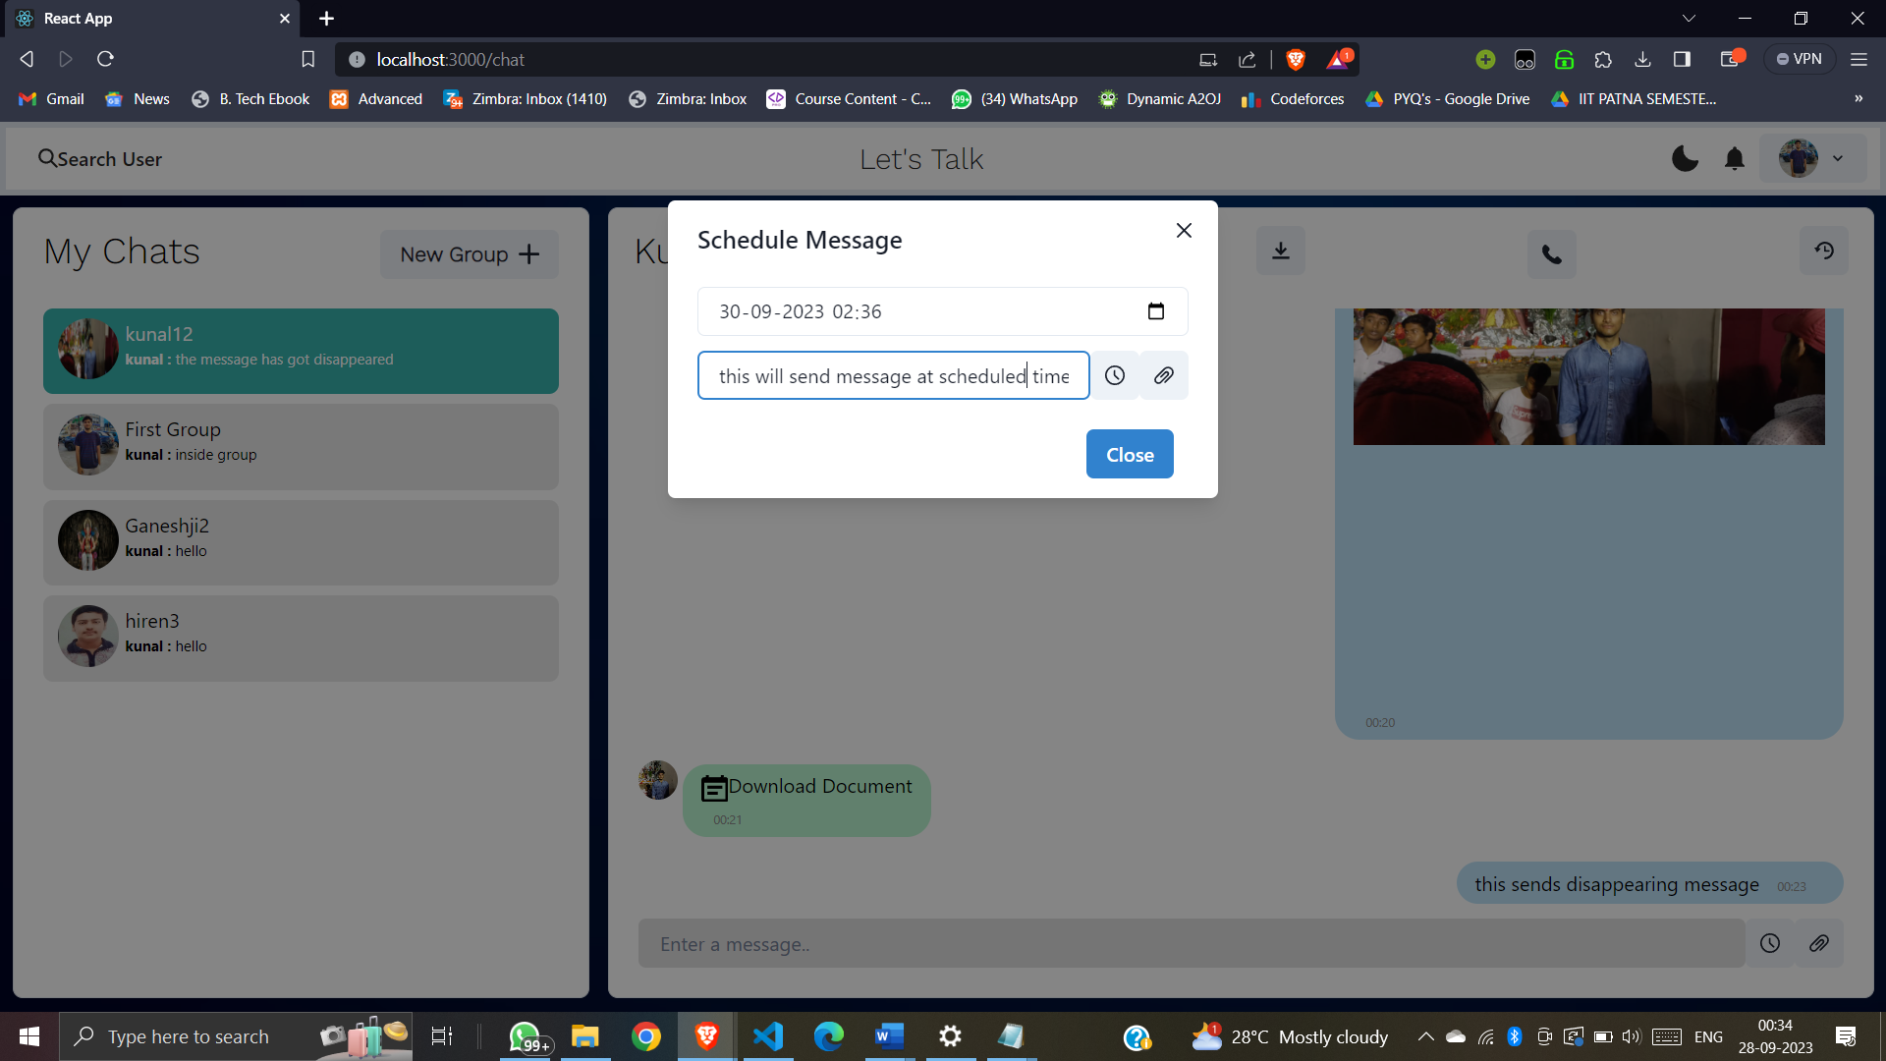

There is a video calling feature as well . When we click it the following screen appears . We can generate an ID , copy it and send it to second user .

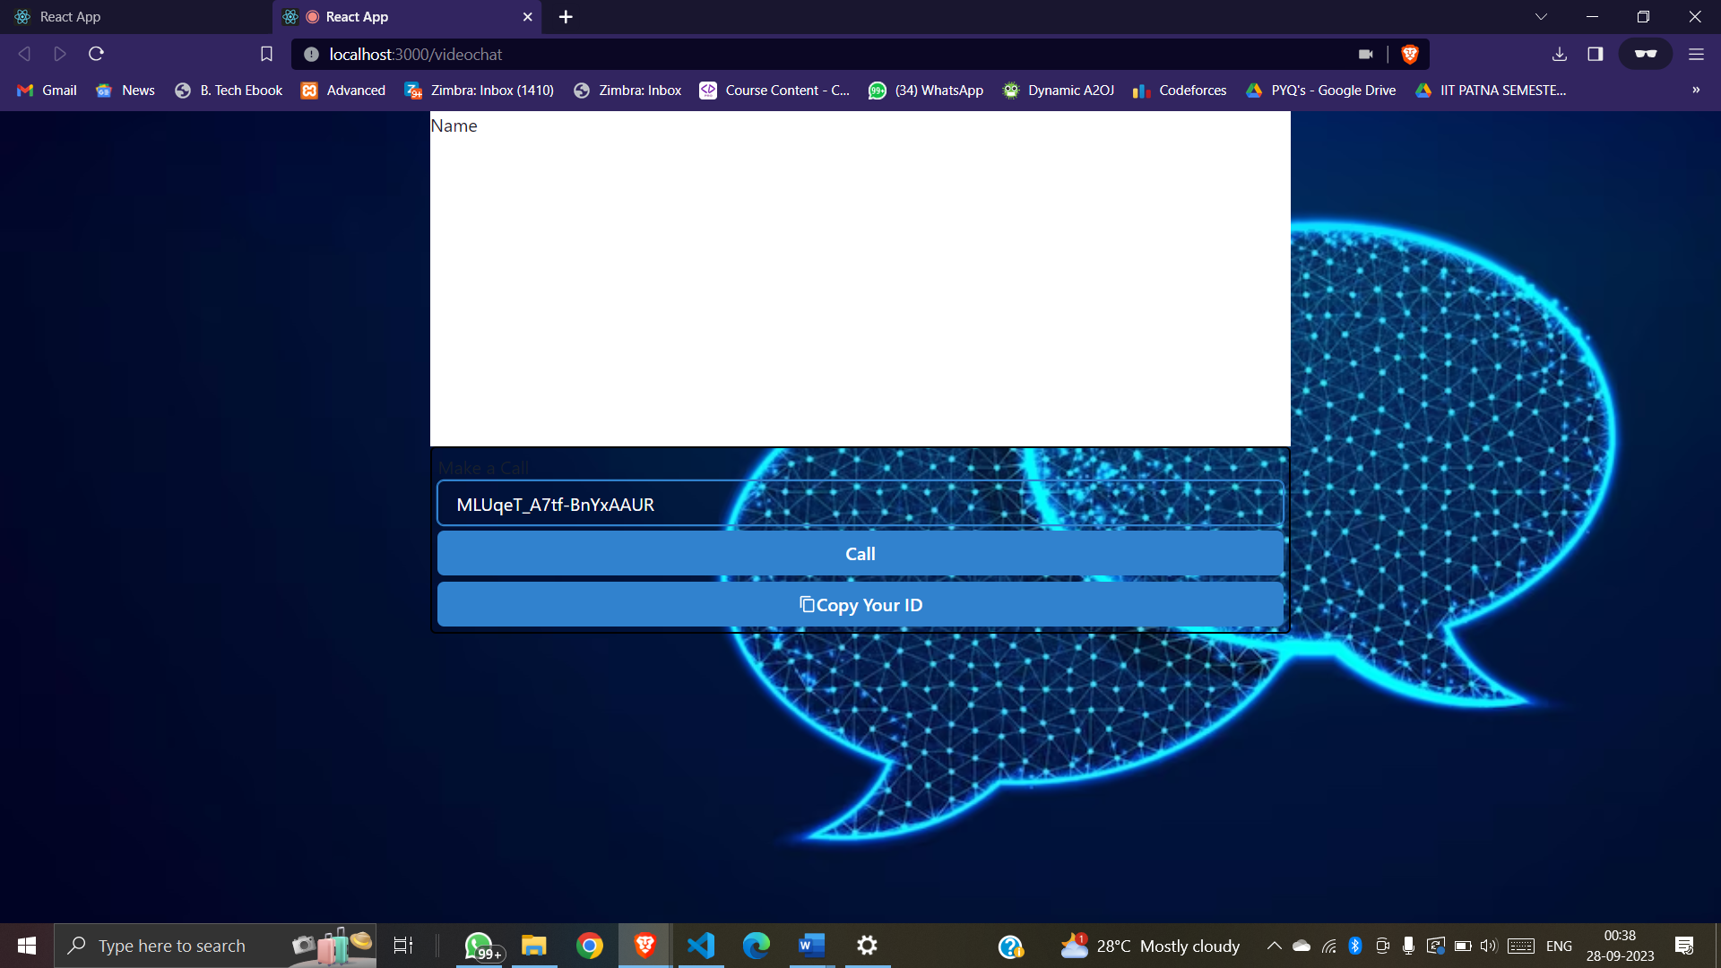

Now from the second user account when I click on call after entering the ID I will receive an option to answer the call .

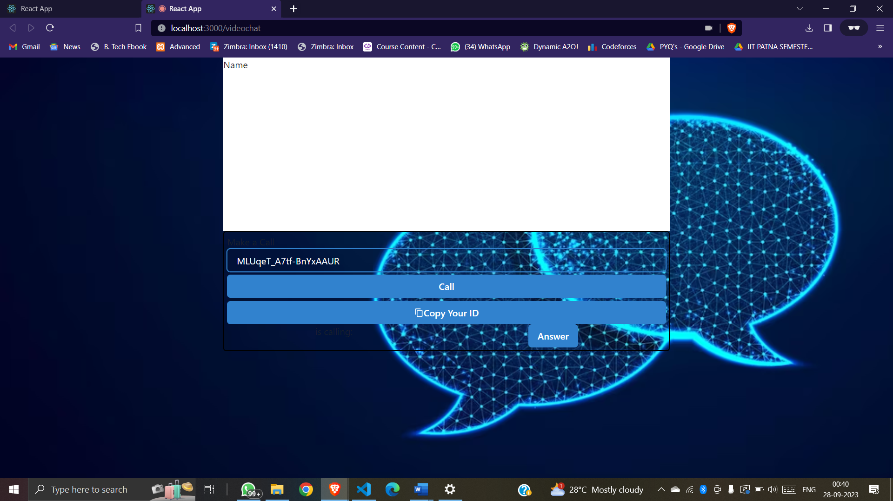

Now after clicking answer me and my friend both are in video call .

There are option to hang up the call any time as well .

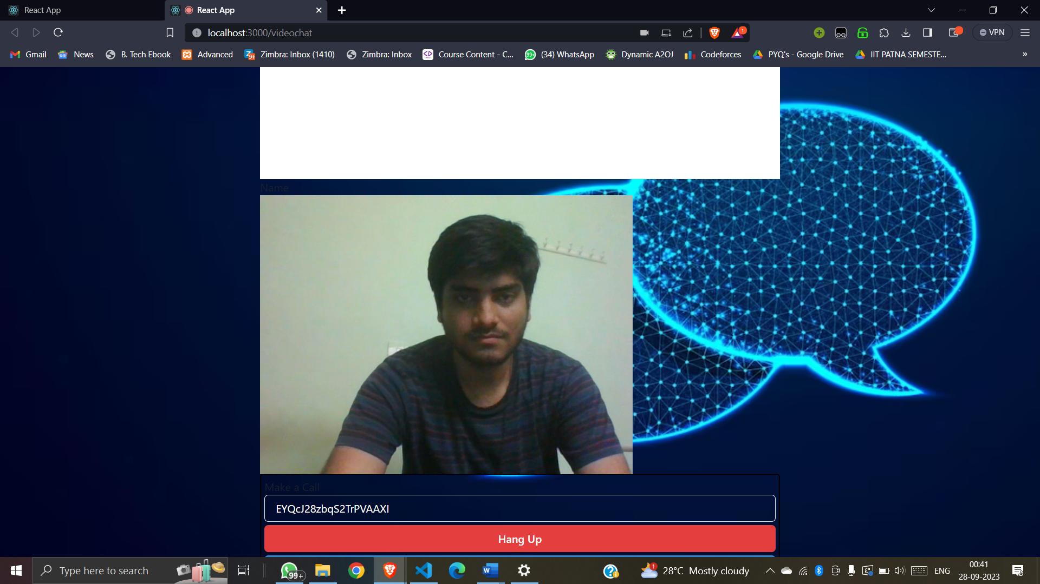

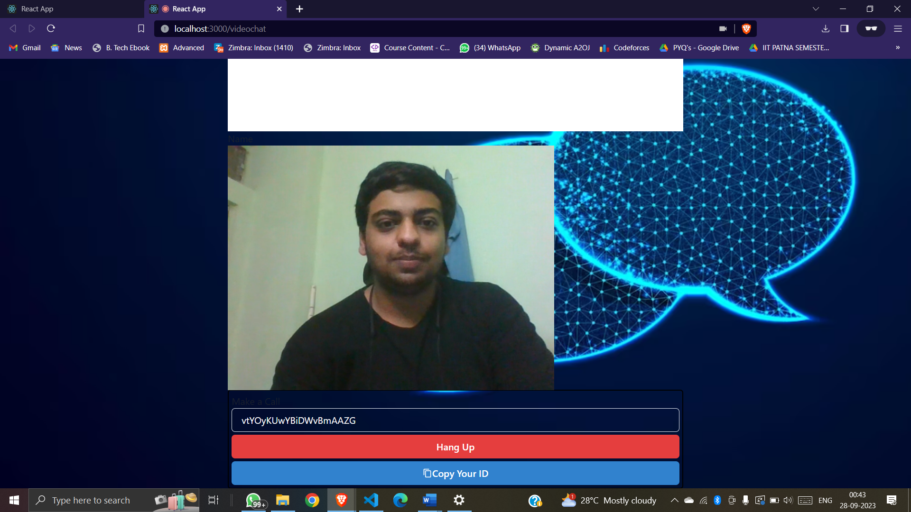

We can also copy or delete any message which we want .

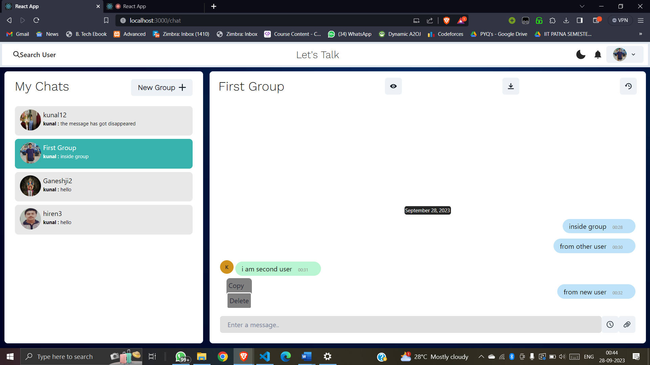

Copy or delete

THANK YOU